28

UNEMPLOYMENT

WHAT’S NEW IN THE SEVENTH EDITION:

A new In the News feature on “Why Has Employment Declined” has been added and all statistics and tables have been updated.

LEARNING OBJECTIVES:

By the end of this chapter, students should understand:

➢ the data used to measure the amount of unemployment.

➢ how unemployment can result from minimum-wage laws.

➢ how unemployment can arise from bargaining between firms and unions.

➢ how unemployment results when firms choose to pay efficiency wages.

CONTEXT AND PURPOSE:

Chapter 15 is the fourth chapter in a four-chapter sequence on the level and growth of output in the long run. In Chapter 12, we learned that capital and labor are among the primary determinants of output and growth. In Chapter 13, we addressed how saving and investment in capital goods affect the production of output. In Chapter 14, we learned about some of the tools people and firms use when choosing capital projects in which to invest. In Chapter 15, we see how full utilization of our labor resources improves the level of production and our standard of living.
The purpose of Chapter 15 is to introduce students to the labor market. We will see how economists measure the performance of the labor market using unemployment statistics. We will also address a number of sources of unemployment and some policies that the government might use to lower certain types of unemployment.

KEY POINTS:

• The unemployment rate is the percentage of those who would like to work who do not have jobs. The Bureau of Labor Statistics calculates this statistic monthly based on a survey of thousands of households.

• The unemployment rate is an imperfect measure of joblessness. Some people who call themselves unemployed may actually not want to work, and some people who would like to work have left the labor force after an unsuccessful search and therefore are not counted as unemployed.

• In the U.S. economy, most people who become unemployed find work within a short period of time. Nonetheless, most unemployment observed at any given time is attributable to the few people who are unemployed for long periods of time.

• One reason for unemployment is the time it takes for workers to search for jobs that best suit their tastes and skills. This frictional unemployment is increased as a result of unemployment insurance, a government policy designed to protect workers’ incomes.

• A second reason our economy always has some unemployment is minimum-wage laws. By raising the wage of unskilled and inexperienced workers above the equilibrium level, minimum-wage laws raise the quantity of labor supplied and reduce the quantity demanded. The resulting surplus of labor represents unemployment.

• A third reason for unemployment is the market power of unions. When unions push the wages in unionized industries above the equilibrium level, they create a surplus of labor.

• A fourth reason for unemployment is suggested by the theory of efficiency wages. According to this theory, firms find it profitable to pay wages above the equilibrium level. High wages can improve worker health, lower worker turnover, raise worker quality, and increase worker effort.

CHAPTER OUTLINE:

I. Unemployment can be divided into two categories.

A. The economy’s natural rate of unemployment refers to the amount of unemployment that the economy normally experiences.

B. Cyclical unemployment refers to the year-to-year fluctuations in unemployment around its natural rate.

II. Identifying Unemployment

A. How Is Unemployment Measured?

1. The Bureau of Labor Statistics (BLS) surveys about 60,000 households every month.

2. The BLS places each adult (age 16 or older) into one of three categories: employed, unemployed, or not in the labor force.

Figure 1

Ask students which category they are in. Remind them that to be considered to be unemployed, they must be without a job and looking for work. Many students are not in the labor force, but may consider themselves to be unemployed simply because they do not have a job. Explain to students that the unemployment rate is a useful statistic because it answers the following question: Of those in the economy who want to work, what percentage cannot find a job?



3. Definition of labor force: the total number of workers, including both the employed and the unemployed.

4. Definition of unemployment rate: the percentage of the labor force that is unemployed.
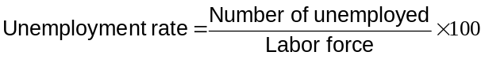

5. Definition of labor-force participation rate: the percentage of the adult population that is in the labor force.

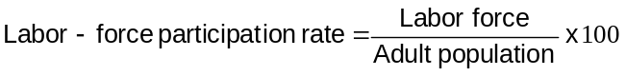

6. Example: Data from 2012. In that year, there were 142.5 million employed people and 12.5 million unemployed people.

a. Labor Force = 142.5 + 12.5 = 155.0 million.

b. Unemployment Rate = (12.5/155.0) × 100 = 8.1%.

c. Because the adult population was 243.3 million, the labor-force participation rate was:

Labor-Force Participation Rate = (155.0/243.3) × 100 = 63.7%.
Make sure that students understand how to make these calculations. Make sure that the formula is written on the board and refer to it often.

ALTERNATIVE CLASSROOM EXAMPLE:
The country of Bada has collected the following information:

Population 240,000
Employed 180,000
Unemployed 30,000

Labor Force = 180,000 + 30,000 = 210,000
Unemployment rate = (30,000/210,000) × 100 = 14.3%
Labor-force participation rate = (210,000/240,000) × 100 = 87.5%

Table 1

7. Table 1 shows unemployment and labor-force participation rates for various sub-groups of the U.S. population.

a. Women of prime working age (25 to 54 years old) have lower rates of labor-force participation than men, but once in the labor market, men and women have similar rates of unemployment.

b. Prime-age blacks have similar labor-force participation rates as prime-age whites, but they have much higher rates of unemployment.

c. Teenagers have much lower rates of labor-force participation and much higher rates of unemployment than older workers.

Figure 2

8. Figure 2 shows the unemployment rate in the United States since 1960.

B. Definition of the natural rate of unemployment: the normal rate of unemployment around which the unemployment rate fluctuates.

C. Definition of cyclical unemployment: the deviation of unemployment from its natural rate.
Discuss how the age composition of the labor force and other demographic and social factors can cause the natural rate of unemployment to vary over time. For 2012, economists at the Congressional Budget Office have estimated a natural rate of 5.5%.

D. Case Study: Labor-Force Participation of Men and Women in the U.S. Economy

1. There has been a dramatic rise in the labor-force participation rates of women over the past 60 years.

Figure 3
2. Figure 3 shows this rise in the labor-force participation rate of women. The figure also shows that the labor-force participation rates for men have actually fallen by a small amount over the same time period.

E. Does the Unemployment Rate Measure What We Want It To?

1. Measuring the unemployment rate is not as straightforward as it may seem.

2. There is a tremendous amount of movement into and out of the labor force.

a. Many of the unemployed are new entrants or re-entrants looking for work.

b. Many unemployment spells end with a person leaving the labor force as opposed to actually finding a job.

3. There may be individuals who are calling themselves unemployed to qualify for government assistance, yet they are not trying hard to find work. These individuals are more likely not a part of the true labor force, but they will be counted as unemployed.

4. Definition of discouraged workers: individuals who would like to work but have given up looking for a job.

a. These individuals will not be counted as part of the labor force.

b. Thus, while they are likely a part of the unemployed, they will not show up in the unemployment statistics.

Table 2

5. Table 2 presents other measures of labor underutilization calculated by the Bureau of Labor Statistics.

Activity 1—Who Is Unemployed?

Type: In-class assignment
Topics: Unemployment categories
Materials needed: None
Time: 5 minutes
Class limitations: Works in any size class

Purpose
This assignment helps familiarize students with labor-force statistics.

Instructions
Ask the students to classify each of the following individuals in one of the following categories: employed, unemployed, or not in the labor force.

1. Steve worked 40 hours last week in an office supply store.
2. Last week, Elizabeth worked 10 hours as a computer programmer for the National Video Company and attended night classes at the local college. She would prefer a full-time job.
3. Roger lost his job at the R-gone Manufacturing Company. Since then he has been trying to find a job at other local factories.
4. Linda is a homemaker. Last week she was occupied with her normal household chores. She neither held a job nor looked for a job.
5. Linda’s father is unable to work.
6. Scott has a Ph.D. He worked full-time but does not like his job as a dishwasher. He has applied for jobs with three companies and five universities. As soon as he gets an offer, he will quit his current job.
7. Mary-Helen has been out of work for a full year. She would take a job if it was offered, but no local companies are hiring. She is not actively searching for work.

Common Answers and Points for Discussion
Steve, Elizabeth, and Scott are employed. Roger is unemployed. Linda, Linda’s father, and Mary-Helen are not in the labor force.

This assignment can also be used to discuss measurement problems such as underemployment (Elizabeth and Scott are examples) and discouraged workers (Mary-Helen provides an example).

F. How Long Are the Unemployed without Work?

1. Another important variable that policymakers may be concerned with is the duration of unemployment.

2. Most spells of unemployment are short, and most unemployment observed at any given time is long term.

G. Why Are There Always Some People Unemployed?

1. In an ideal labor market, wages would adjust so that the quantity of labor supplied and the quantity of labor demanded would be equal.

2. However, there is always unemployment even when the economy is doing well. The unemployment rate is never zero; it fluctuates around the natural rate.

a. Definition of frictional unemployment: unemployment that results because it takes time for workers to search for the jobs that best suit their tastes and skills.

b. Definition of structural unemployment: unemployment that results because the number of jobs available in some labor markets is insufficient to provide a job for everyone who wants one.

c. Three possible reasons for structural unemployment are minimum-wage laws, unions, and efficiency wages.

H. FYI: The Jobs Number

1. When the Bureau of Labor Statistics announces the unemployment rate each month, it also announces the number of jobs the economy gained or lost.

2. This information comes from a survey of 160,000 business establishments.

III. Job Search

A. Definition of job search: the process by which workers find appropriate jobs given their tastes and skills.

B. Because workers differ from one another in terms of their skills and tastes and jobs differ in their attributes, it is often difficult for workers to match with the appropriate job.

C. Why Some Frictional Unemployment Is Inevitable

1. Frictional unemployment often occurs because of a change in the demand for labor among different firms.

a. When consumers decide to stop buying a good produced by Firm A and instead start buying a good produced by Firm B, some workers at Firm A will likely lose their jobs.

b. New jobs will be created at Firm B, but it will take some time to move the displaced workers from Firm A to Firm B.

c. The result of this transition is a period of unemployment.

d. The same situation can occur across industries and regions as well.

2. This implies that, because the economy is always changing, frictional unemployment is inevitable. Workers in declining industries will find themselves looking for new jobs, and firms in growing industries will be seeking new workers.

D. Public Policy and Job Search

1. The faster information spreads about job openings and worker availability, the more rapidly the economy can match workers and firms.

2. Government programs try to facilitate job search in various ways.

a. Government-run employment agencies give out information on job vacancies.

b. Public training programs can ease the transition of workers from declining to growing industries and help disadvantaged groups escape poverty.

3. Critics of these programs argue that the private labor market will do a better job of matching workers with employers and therefore the government should not be involved in the process of job search.

E. Unemployment Insurance

1. Definition of unemployment insurance: a government program that partially protects workers’ incomes when they become unemployed.

2. Because unemployment insurance reduces the hardship of unemployment, it also increases the amount of unemployment that exists.

3. Many studies have shown that more generous unemployment insurance benefits lead to reduced job search effort and, as a result, more unemployment.

4. In the News: Why Has Employment Declined?

a. The number of Americans receiving government benefits has grown substantially recently while the employment-population ratio has declined.

b. This article from The Wall Street Journal discusses the incentives created by these government benefits and the effects on the annual rate of real output growth.

IV. Minimum-Wage Laws

A. Unemployment can also occur because of minimum-wage laws.

Figure 4

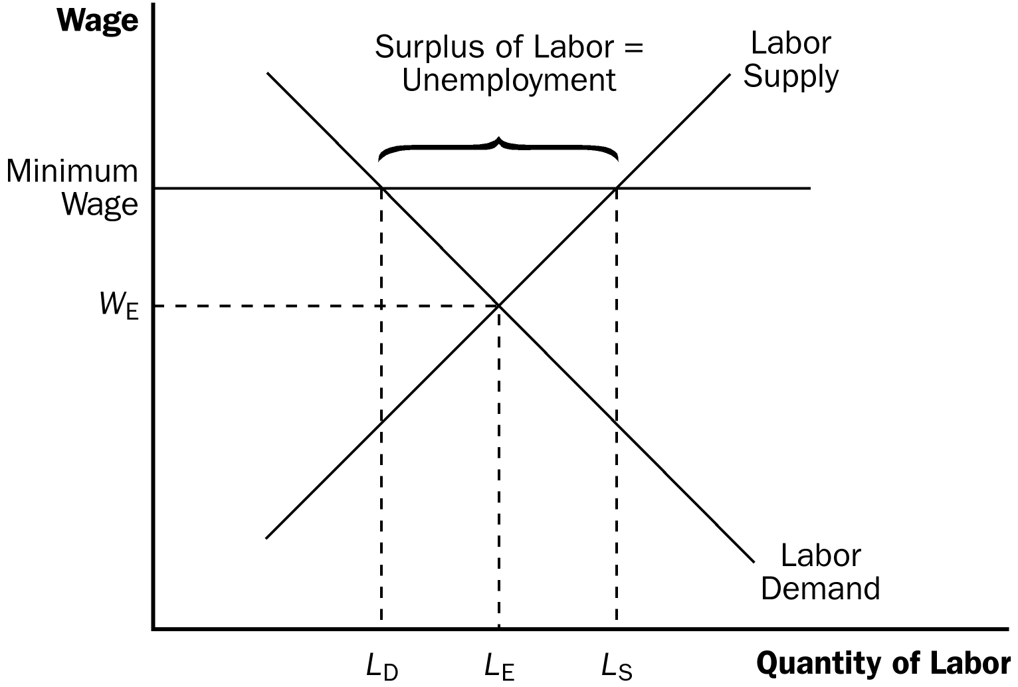

1. If the minimum wage is set above the equilibrium wage in the labor market, a surplus of labor will occur.

2. While minimum-wage laws are one reason unemployment exists in the U.S. economy, they do not affect everyone.

a. The vast majority of workers in the economy have wages well above the legal minimum, so the law does not prevent most wages from adjusting to balance supply and demand.

b. Minimum-wage laws therefore have the largest affect on the least skilled and least experienced members of the labor force, such as teenagers.

B. Anytime a wage is kept above the equilibrium level for any reason, the result is unemployment.

1. Other causes of this situation include unions and efficiency wages.

2. This situation is different from frictional unemployment where the search for the right job is the reason for unemployment.

C FYI: Who Earns the Minimum Wage?

1. In 2012, the Department of Labor released a study of which workers reported earnings at or below the minimum wage in 2011.

a. Of those workers paid an hourly rate, about 4% of men and 6% of women reported wages at or below the federal minimum.

b. Minimum-wage workers tend to be young, with about half under the age of 25.

c. Minimum-wage workers tend to be less educated. Of those workers ages 16 and over with a high school education, only 5% earned the minimum wage.

d. Minimum-wage workers are more likely to be working part time.

d. The industry with the highest proportion of workers with reported hourly wages at or below the minimum wage was leisure and hospitality.

e. The proportion of workers earning the prevailing minimum wage has changed substantially over time, trending downward from 1979 to 2006 then increasing in 2011. The increase is partially attributable to an increase in the minimum wage.

V. Unions and Collective Bargaining

A. Definition of union: a worker association that bargains with employers over wages and working conditions.

B. Unions play a smaller role in the U.S. economy today than they did in the past. However, unions continue to be prevalent in many European countries.

C. The Economics of Unions

1. Definition of collective bargaining: the process by which unions and firms agree on the terms of employment.

2. Unions try to negotiate for higher wages, better benefits, and better working conditions than the firm would offer if there were no union.

3. Definition of strike: the organized withdrawal of labor from a firm by a union.

4. Economists have found that union workers typically earn 10% to 20% more than similar workers who do not belong to unions.

5. This implies that unions raise the wage above the equilibrium wage, resulting in unemployment.

a. Unions are often believed to cause conflict between insiders (who benefit from high union wages) and outsiders (who do not get the union jobs).

b. Outsiders will either remain unemployed or find jobs in firms that are not unionized.

c. The supply of workers in nonunion firms will increase, pushing wages at those firms down.

D. Are Unions Good or Bad for the Economy?

1. Critics of unions argue that unions are a cartel, which causes inefficiency because fewer workers end up being hired at the higher union wage.

2. Advocates of unions argue that unions are an answer to the problems that occur when a firm has too much power in the labor market (for example, if it is the only major employer in town). In addition, by representing workers’ views, unions help firms provide the right mix of job attributes.

VI. The Theory of Efficiency Wages

A. Definition of efficiency wages: above-equilibrium wages paid by firms in order to increase worker productivity.

B. Efficiency wages raise the wage above the market equilibrium wage, resulting in unemployment.

C. There are several reasons why a firm may pay efficiency wages.

1. Worker Health

a. Better-paid workers can afford to eat better and can afford good medical care.

b. This is more applicable in developing countries where inadequate nutrition can be a significant problem.

2. Worker Turnover

a. A firm can reduce turnover by paying a wage greater than its workers could receive elsewhere.

b. This is especially helpful for firms that face high hiring and training costs.

3. Worker Quality

a. Offering higher wages attracts a better pool of applicants.

b. This is especially helpful for firms that are not able to perfectly gauge the quality of job applicants.

4. Worker Effort

a. Again, if a firm pays a worker more than he or she can receive elsewhere, the worker will be more likely to try to protect his or her job by working harder.

b. This is especially helpful for firms that have difficulty monitoring their workers.

5. Case Study: Henry Ford and the Very Generous $5-a-Day Wage

a. Henry Ford used a high wage (about twice the going rate) to attract better employees.

b. After instituting this higher wage policy, the company’s production costs actually fell due to reduced turnover, absenteeism, and shirking.
When discussing the material in this chapter, you may find that students want to begin discussing possible policies to deal with unemployment. Keep the focus on institutional responses such as unemployment insurance, job training, and government-sponsored employment agencies.


SOLUTIONS TO TEXT PROBLEMS:

Quick Quizzes

1. The unemployment rate is measured starting with a survey of about 60,000 households. The BLS categorizes individuals surveyed as employed, unemployed, and not in the labor force. Next, the BLS computes the labor force as the sum of the number of employed and the number of unemployed. Finally, the unemployment rate is calculated as the number of unemployed divided by the labor force multiplied by 100. The unemployment rate overstates the amount of joblessness because some of those who report being unemployed may not, in fact, be trying hard to find a job. But the unemployment rate may understate the amount of joblessness because discouraged workers are considered not in the labor force even though they are workers without jobs.

2. An increase in the world price of oil increases the amount of frictional unemployment as oil-producing firms increase output and employment, but other firms, such as those in the auto industry, reduce output and employment. The sectoral shift from the auto industry to oil firms causes higher frictional unemployment for a time until workers have shifted from the auto industry to the oil industry. Although no increase in unemployment is really desirable, this type of frictional unemployment is a natural outcome of the reallocation of resources between different sectors. Public policies that might affect the unemployment caused by this change in the price of oil include government-run employment agencies, which can help autoworkers move into the oil industry, job-training programs to help workers adapt to a new industry, and unemployment insurance, which keeps workers from suffering economic hardship while changing from one industry to another.

3. Figure 1 shows the supply curve (S) and the demand curve (D) for labor. The wage (W) is above the equilibrium wage (W_{E}). The result is unemployment, equal to the amount by which the quantity of labor supplied (L_{S}) exceeds the quantity of labor demanded (L_{D}).

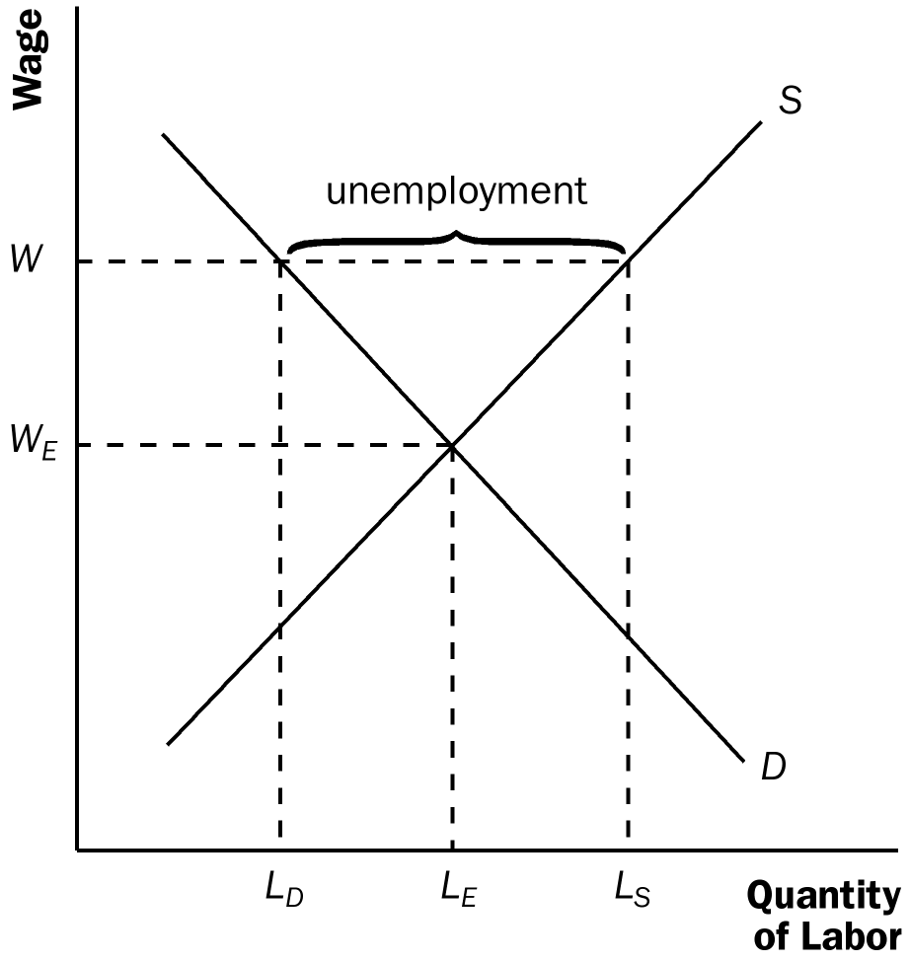

Figure 1

4. A union in the auto industry raises the wages of workers employed by General Motors and Ford by threatening to strike. To prevent the costs of a strike, the firms generally pay higher wages than they would if there were no union. However, the higher wages reduce employment at General Motors and Ford. The unemployed autoworkers seek jobs elsewhere, reducing wages and increasing employment in the nonunion sector.

5. There are four reasons that firms might find it profitable to pay wages above the level that balances the quantity of labor supplied and the quantity of labor demanded: (1) to ensure that workers are in good health so they will be more productive; (2) to reduce worker turnover because it is costly to hire new workers; (3) to make workers eager to keep their jobs, thus discouraging them from shirking; and (4) to attract a better pool of workers.

Questions for Review

1. The BLS categorizes each adult (16 years of age and older) as employed, unemployed, or not in the labor force. The labor force consists of the sum of the employed and the unemployed. The unemployment rate is the percentage of the labor force that is unemployed. The labor-force participation rate is the percentage of the total adult population that is in the labor force.

2. Unemployment is typically short term. Most people who become unemployed are able to find new jobs fairly quickly. But most unemployment observed at any given time is attributable to the relatively few workers who are jobless for long periods of time.

3. Frictional unemployment is inevitable because the economy is always changing. Some firms are shrinking while others are expanding. Some regions are experiencing faster growth than other regions. Transitions of workers between firms and between regions are accompanied by temporary unemployment.

The government could help to reduce the amount of frictional unemployment through public policies that provide information about job vacancies in order to match workers and jobs more quickly, and through public training programs that help ease the transition of workers from declining to expanding industries and help disadvantaged groups escape poverty.

4. Minimum-wage laws are a better explanation for unemployment among teenagers than among college graduates. Teenagers have fewer job-related skills than college graduates do, so their wages are low enough to be affected by the minimum wage. College graduates' wages generally exceed the minimum wage.

5. Unions affect the natural rate of unemployment via the effect on insiders and outsiders. Because unions raise the wage above the equilibrium level, the quantity of labor demanded declines while the quantity supplied of labor rises, so there is unemployment. Insiders are those who keep their jobs. Outsiders, workers who become unemployed, have two choices: either get a job in a firm that is not unionized, or remain unemployed and wait for a job to open up in the union sector. As a result, the natural rate of unemployment is higher than it would be without unions.

6. Advocates of unions claim that unions are good for the economy because they are an antidote to the market power of the firms that hire workers and they are important for helping firms respond efficiently to workers' concerns.

7. Four reasons why a firm's profits might increase when it raises wages are: (1) better paid workers are healthier and more productive; (2) worker turnover is reduced; (3) the firm can attract higher quality workers; and (4) worker effort is increased.

Quick Check Multiple Choice
1. a
2. c
3. b
4. b
5. c
6. a

Problems and Applications

1. a. The adult population consists of the number of employed (143,322,000) plus the number of unemployed (12,332,000) plus those not in the labor force (89,008,000), which equals 244,662,000.

b. The labor force consists of the number of employed (143,322,000) plus the number of unemployed (12,332,000), which equals 155,654,000.

c. The labor-force participation rate is the labor force (155,654,000) divided by the adult population (244,662,000) times 100, which equals 63.6%.

d. The unemployment rate is the number of unemployed (12,332,000) divided by the labor force (155,654,000) times 100, which equals 7.9%.

2. Many answers are possible.

3. The fact that employment increased 4.9 million while unemployment declined 2.7 million is consistent with growth in the labor force of 2.2 million workers. The labor force constantly increases as the population grows and as labor-force participation increases, so the increase in the number of people employed may exceed the reduction in the number unemployed.

4. a. If an auto company goes bankrupt and its workers immediate begin looking for work, the unemployment rate will rise and the employment-population ratio will fall.

b. If some of the unemployed auto workers give up looking for a job, the unemployment rate will fall and the employment-population ratio will remain the same.

c. If numerous students graduate from college and cannot find work, the unemployment rate will rise and the employment-population ratio will remain unchanged.

d. If numerous students graduate from college and immediately begin new jobs, the unemployment rate will fall and the employment-population ratio will rise.

e. If a stock market boom induces earlier retirement, the unemployment rate will rise and the employment-population ratio will fall.

f. Advances in health care that prolong the life of retirees will not affect the unemployment rate and will lower the employment-population ratio.

5. a. A construction worker who is laid off because of bad weather is likely to experience short-term unemployment, because the worker will be back to work as soon as the weather clears up.

b. A manufacturing worker who loses his job at a plant in an isolated area is likely to experience long-term unemployment, because there are probably few other employment opportunities in the area. He may need to move somewhere else to find a suitable job, which means he will be out of work for some time.

c. A worker in the stagecoach industry who was laid off because of the growth of railroads is likely to be unemployed for a long time. The worker will have a lot of trouble finding another job because his entire industry is shrinking. He will probably need to gain additional training or skills to get a job in a different industry.

d. A short-order cook who loses his job when a new restaurant opens is likely to find another job fairly quickly, perhaps even at the new restaurant, and thus will probably have only a short spell of unemployment.

e. An expert welder with little education who loses his job when the company installs automatic welding machinery is likely to be without a job for a long time, because he lacks the technological skills to keep up with the latest equipment. To remain in the welding industry, he may need to go back to school and learn the newest techniques.

Supply
Wage

w_{M,2}

w_{M,1}

Demand

Quantity
of Labor
L_{D,2}
L_{D,1}
L_{S,2}
L_{S,1}

Figure 2

6. Figure 2 shows a diagram of the labor market with a binding minimum wage. At the initial minimum wage (w_{M,1}), the quantity of labor supplied L_{S,1} is greater than the quantity of labor demanded L_{D,1}, and unemployment is equal to L_{S,1} – L_{D,1}. An increase in the minimum wage to w_{M,2} leads to an increase in the quantity of labor supplied to L_{S,2} and a decrease in the quantity of labor demanded to L_{D,2}. As a result, unemployment increases as the minimum wage rises.

7. a. Figure 3 illustrates the effects of a union being established in the manufacturing labor market. In the manufacturing labor market (figure on the left), the wage rises from the non-union wage, w_{NU}, to the union wage, w_{U}, and the quantity of labor demanded declines from the non-union quantity of labor, L_{NU}, to the union quantity of labor demanded, L_{UD}. Because the wage is higher, the quantity supplied of labor increases to the union quantity of labor supplied L_{US}, so there are L_{US} – L_{UD} unemployed workers in the unionized manufacturing sector.

b. When those workers who become unemployed in the manufacturing sector seek employment in the service labor market, shown in the figure on the right, the supply of labor shifts to the right from S₁ to S₂. The result is a decline in the wage in the nonunionized service sector from w₁ to w₂ and an increase in employment in the nonunionized service sector from L₁ to L₂.

Manufacturing Labor Market
Service Labor Market

Wage
Wage
S
S₁

w_{U}
S₂
w_{NU}
w₁

w₂

D
D
Quantity
of Labor
Quantity
of Labor
L_{UD}
L_{US}
L_{NU}
L₁
L₂

Figure 3

8. a. Wages between the two industries would be equal. If not, new workers would choose the industry with the higher wage, pushing the wage in that industry down.

b. If the country begins importing autos, the demand for domestic auto workers would fall. If the country begins to export aircraft, there would be an increase in the demand for workers in the aircraft industry.

c. In the short run, wages in the auto industry would fall, while wages in the aircraft industry would rise. Over time, new workers would move into the aircraft industry bringing its wage down until wages were equal across the two industries.

d. If the wage did not adjust to its equilibrium level, there would be a shortage of workers in the aircraft industry and a surplus of labor (unemployment) in the auto industry.

9. a. If a firm was not providing such benefits prior to the legislation, the curve showing the demand for labor would shift to the left by exactly $4 at each quantity of labor, because the firm would not be willing to pay as high a wage given the increased cost of the benefits.

b. If employees value the benefit by exactly $4 per hour, they would be willing to work the same amount for a wage that is $4 less per hour, so the supply curve of labor shifts to the right by exactly $4.
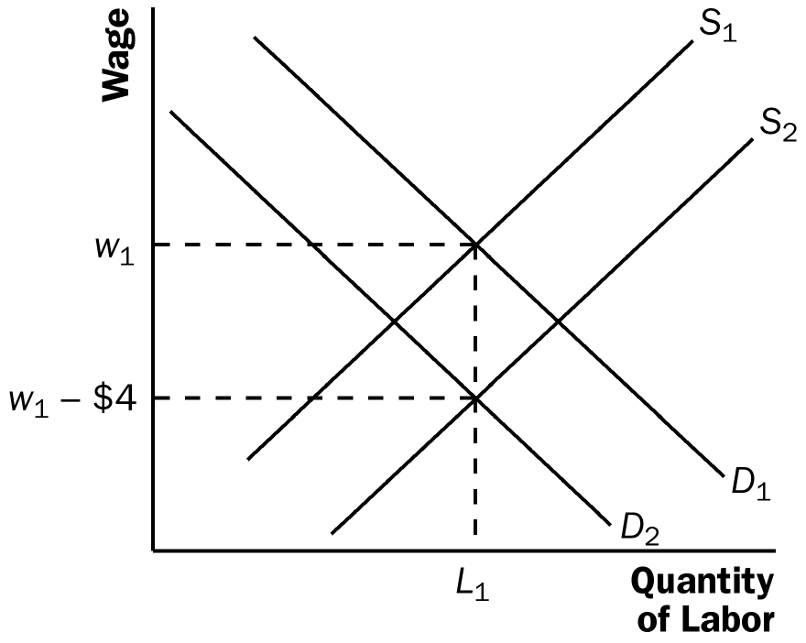

Figure 4

c. Figure 4 shows the equilibrium in the labor market. Because the demand and supply curves of labor both shift by $4, the equilibrium quantity of labor is unchanged and the wage declines by $4. Both employees and employers are just as well off as before.

d. If the minimum wage prevents the wage from falling to the new equilibrium level, the result will be increased unemployment, as Figure 5 shows. Initially, the equilibrium quantity of labor is L₁ and the equilibrium wage is w₁, which is $3 higher than the minimum wage w_{m}. After the law is passed, demand falls to D₂ and supply rises to S₂. Because of the minimum wage, the quantity of labor demanded (L_{D2}) will be smaller than the quantity supplied (L_{S2}). Thus, there will be unemployment equal to L_{S2} – L_{D2}.
Wage
S₁

S₂
w₁

w_{m} = w₁-$3
w₁-$4

D₁
D₂

Quantity
of Labor
L₁
L_{S,2}
L_{D,2}

Figure 5

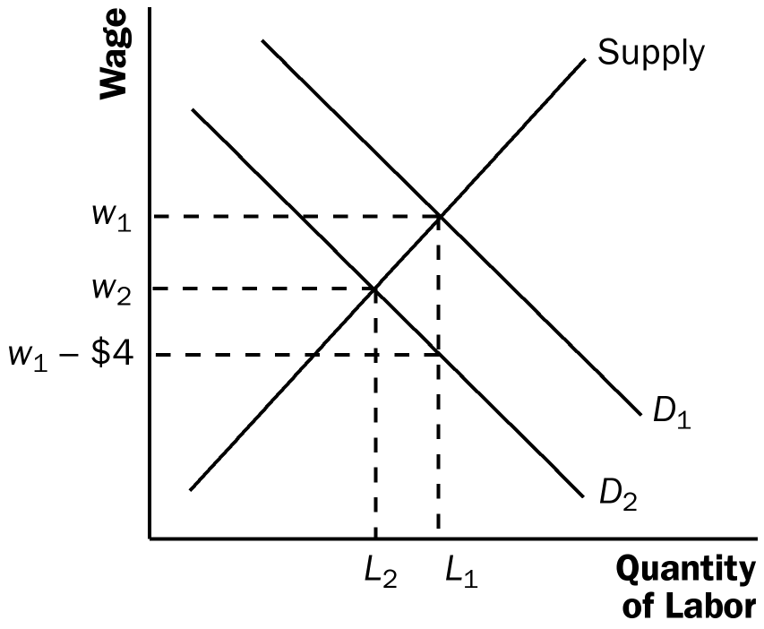

Figure 6

e. If the workers do not value the mandated benefit at all, the supply curve of labor does not shift. As a result, the wage rate will decline by less than $4 and the equilibrium quantity of labor will decline, as shown in Figure 6. Employers are worse off, because they now pay a greater total wage plus benefits for fewer workers. Employees are worse off, because they get a lower wage and fewer are employed.

